Project Name |  | Confidentiality Level
CMS Project |  | For Recipients’ Reference Only
Project ID | Version | Document Code
 | 0.1 | Project ID_SD_001

Contract Management System
Software System Design Specification

15301002 程 辰
15301009 倪施杰



Copyright © Ruankosoft Technologies(Shenzhen), Co., Ltd.
. All Rights Reserved
Revision Record
Date | Revision Version | CR ID /Defect ID | Sec No. | Change Description | Author

Content
1 Introduction 5
1.1 Purpose 5
1.2 Scope 5
1.2.1 Name 5
1.2.2 Functions 5
1.2.3 Applications 5
2 Level 0 Design Description 5
2.1 Software System Context Definition 5
2.2 Design Considerations 5
2.2.1 Design Alternatives 5
2.2.2 Design Constraints 5
2.2.3 Other Design Considerations 6
3 Level 1 Design Description 6
3.1 System Architecture 6
3.1.1 Description of the Architecture 6
3.1.2 Representation of the Business Flow 6
3.2 Decomposition Description 6
3.2.1 Module/Subsystem 1 Description 6
3.2.2 Module/Subsystem 2 Description 6
3.3 Dependency Description 6
4 Level 2 Design Description (Optional) 6
4.1 Module Name 1 7
4.1.1 Design Description 7
4.1.2 Function Illustration 7
4.2 Module Name 2 7
4.2.1 Design Description 7
4.2.2 Function Illustration 7
5 Data Structure/Database Design 7
6 UI Design 7
7 Detailed Design of Module 8
7.1 Class1 Design 8
7.1.1 Overview 8
7.1.2 Class Diagram 8
7.1.3 Attributes 8
7.1.4 Methods 8
7.2 Class2 Design 9

Keywords:
Abstract:
List of abbreviations: Describe abbreviations in this document, full spelling of the abbreviation and Chinese explanation should be provided.>
Abbreviations | Full spelling | Chinese explanation

- Introduction

Purpose
This section should state the purpose of this document. The intended reader should also be specified here.
Describes the contract management system’s design process, including general design and detailed design, in order to conduct project team to implement coding and unit testing.

Scope
    - Name
Identify the software by name.
Contract Management System
    - Functions
Explain what the software product(s) will and will not do (either directly or by reference to another related document).
Please refer to the requirements specification document: requirement analysis of Contract Management System
    - Applications
Describe the application of the product (either directly or by reference to another software document
This software is a web application. The system uses the b/s structure, users only need to access the website through the browser
- Level 0 Design Description

Software System Context Definition
This section should describe the relationships between the software system to be developed and the external entities. Architecture diagrams could be used to describe the architecture and the interactions.
The description of the external entities' attributes shall be limited to these attributes which will interact with the software design. In lieu of a complete description, reference could be made to relevant documentation of the concerned software entity, e.g. OS Programmer's Manual.
Design alternative

Design Considerations
    - Design Alternatives
Analyze several alternatives of system design scheme, and specify the scheme that shall be used.
    - Design Constraints
      - Standards compliance
Describe standards that software system shall comply with. Hardware Limitations 硬件限制
Describe hardware limitations of the software system.
The minimum configuration of the hardware:
CPU: 1GHZ
RAM: 128MB
      - Technology Limitations
Describe technology limitations of the software system.
Database: MySQL
Coding standard: COE projecting standard requirement of Ruanko Lab.
    - Other Design Considerations
Describe other design considerations of the software system.
- Level 1 Design Description

System Architecture
The function are divided into several modules to manage and develop respectively. System is divided into 6 modules: Register, login, Contract Management, Query, Fundamental Data Management, System Management.
    - Description of the Architecture
The software system architecture should be described here. Architecture diagrams, hierarchical decomposition diagrams, or package diagrams could be used to represent the architecture. And the partitioning principle, such as the architecture defined in a standard protocol, a scheme coming from the analysis model, or the constraints to be followed to integrate with the legacy systems, should also be depicted. The responsibilities and relationships of the analysis classes should be clarified while an analysis model is introduced.
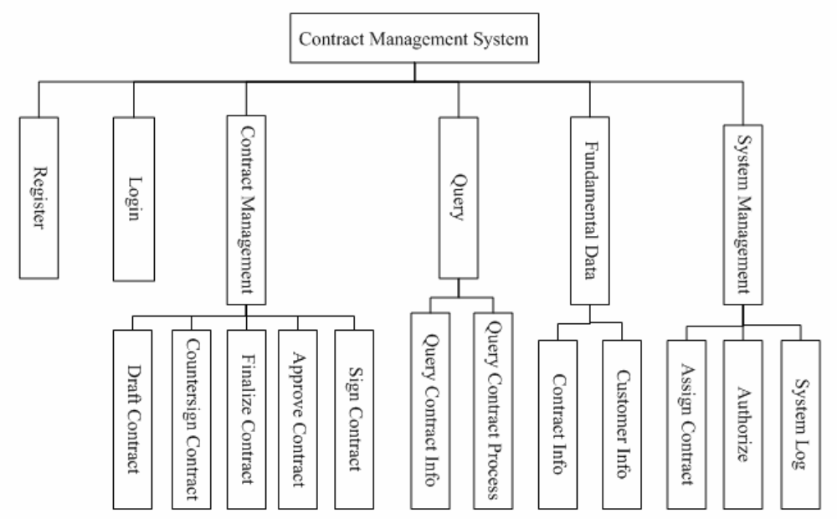
    - Representation of the Business Flow
Sequence diagrams or collaboration diagrams could be used to illustrate the specific use case(s) scenarios from the use-case model to represent the final system architecture or analysis classes，and how these architectural modules work.
Contract Management:
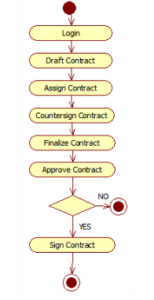

Decomposition Description
This section describes the packages, sub-systems, modules in the system.

    - Module/Subsystem 1 Description
Don't actually write "Module name (1)". Specify the name of the module in few words.

Describe as follows:
1. Overview
2. Functions
    - Module/Subsystem 2 Description

Dependency Description
This section describes the relationships among the design entities such as sub-systems, data stores, modules, processes, etc.
Structure charts, transaction diagrams could be used to represent dependences.
- Level 2 Design Description (Optional)
Each module that is defined in L1 and identified for further description shall be stated by separate sub-sections as mentioned below. More sub-section levels could be added optionally, and finally all specific classes corresponding to each final minimal module, including its public attributes and pubic methods, should be defined.
This will be repeated for each package/module as follows.

Module Name 1
Don't actually write "Module name (1)". Specify the name of the module in few words.
    - Design Description
Depict the decomposition of the modules e.g. the functionality of each sub modules. The design classes should be defined here, class diagrams could be used to describe the design classes and the relationships among these classes, and the design pattern(s) should also be interpreted.
This will be repeated for each class as follows.
      - Class name1
Should be replaced by a true design class name.
Specific classes corresponding to each final minimal module should be defined as below.
(1) Overview
Overview of its responsibilities.

(2) Definition (Optional)
Class diagrams or pseudo codes could be used to depict the class definitions in detail，if it is not described previously. All the public attributes and methods should be defined specifically.
      - Class name2
(1) Overview
(2) Definition (Optional)

    - Function Illustration
Sequence diagrams or collaboration diagrams, etc. could be used to represent the relationships among the design classes and how the design classes implement their typical responsibilities.

Module Name 2
    - Design Description
      - Class name1
      - Class name2
    - Function Illustration

- Data Structure/Database Design
Design and describe the data storage format.
- UI Design
Describe the design of each user interface
- Register Page and Login Page
- Contract Management page: draft, countersign, finalize, approve, sign, contract details page, contract list page, countersign comment page.
- System management page
- Detailed Design of Module

Class1 Design
    - Overview
Recount the responsibilities and functions of the class. Sequence diagrams, collaboration diagrams, or state chart diagrams can be used to depict the realizations, if it’s not described previously. If necessary, the static and dynamic relationships with the related classes could also be described.
Contract entity class: used to set up the mapping relation between database table, declare private properties and corresponding field in database table, provide initialize constructed function, setter and getter function is provided for external call, the entity class in project as the carrier of data transmission

    - Class Diagram
Class diagram, if not described in HLD.
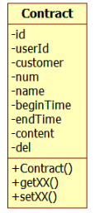
    - Attributes
The common data structure should be described here.
Visibility | Name | Type | Brief descriptions
Private | Id | Int | ID
Private | userId | Int | User id
Private | Customer | String | Customer
private | Mum | String | Contract mumber
private | Name | String | Contract name
Private | beginTime | Data | Begin time
Private | endTime | Data | End time
Private | Content | String | Contrat content
Private | del | int | Delete status(0-not deleted, 1-deleted)
    - Methods
Every method should be described
.setId（）
      - Method1
(1) Method Descriptions
Prototype | Public void setId()
Description | Set the attribute’s valdude
Calls
Called By
Input | Id
Output | Void
Return | Void
Exception | Void

(2) Implementation Descriptions
Pseudo codes could be used to depict the method definitions. This is the most important part of LLD
Set the id property of contract.
      - Method2

Class2 Design

